

Facilitator Guide

Getting started with the Digital Service Standard



© Commonwealth of Australia (Digital Transformation Agency) 2017

With exception of the Commonwealth Coat of Arms and where otherwise noted, all material presented within this training package is provided under a Creative Commons Attribution - NonCommercial (version 4.0) licence.

# Contents

1. **Welcome** 4
2. **Foundations** 16
3. **Users** 27
4. **Adaptability** 34
5. **Design** 41
6. **Simplicity** 47
7. **Conclusion** 52
8. **Appendix** 54

# Welcome

The Australian Government is undergoing a process of digital transformation, improving the way we build and manage services.

To support agencies, and help them meet the Digital Service Standard, the Digital Transformation Agency (DTA) has developed this training package. It is provided, free of charge, to help build organisational capability in introductory digital skills and mindsets.

### Purpose of the training

This course is designed to provide an introductory awareness of the Digital Service Standard (the Standard). It is not designed to provide skills in applying or assessing against the Standard, though it is still useful background information for anyone needing to understand and use the Standard.

### What is the Digital Service Standard?

The Standard helps support digital teams build government services that are simple, clear and fast. It is not a checklist, but rather a set of best practice principles for how digital teams should work. Guidance on the Standard, where it applies, and the assessment process is provided at <https://www.dta.gov.au/standard/>.

##### Terminology

Throughout the training, the term ‘Digital Service Standard’ has been shortened to ‘the Standard’. Please ensure participants are aware of this so they can follow easily. The Digital Transformation Agency (DTA) prefers this shortened form, rather than DSS, which is commonly associated with the Department of Social Services.

This course, called ‘Getting started with the Digital Service Standard’ has also be shortened throughout the facilitator guide to ‘Getting started’ for brevity.

Within this document, the terms ‘course’ or ‘training’ have been used interchangeably and refer to the entire learning package. Within the course, information and activities have been split into five ‘modules’

(typically 1 hour long) which are independent but related learning packages. Each module is made up of a number of ‘sessions’ (typically 15-30 minutes in duration), which is synonymous with ‘activities’. The term ‘facilitator’ means any person delivering the training. Agencies may use different terminology than presented here.

### About this course

##### Who is this training for?

This course is suitable for government employees who require a basic understanding of the Standard, including those who have just started working in service teams or are working alongside service teams, in roles such as:

* policy
* legal
* communications
* support or corporate functions

Staff with experience working in service teams applying the Standard may be already sufficiently across some of the introductory themes covered in this training. They might like to attend the training as a subject matter expert (SME) to lend their experience and knowledge.

##### Learning outcomes

At the end of the training, participants are expected to have an improved understanding of:

1. The mindset, skillset and tools required to meet the Standard.
2. Mandate for and scope of the Standard.
3. Their role in supporting digital transformation and contributing to simple, clear and fast services.

Individual learning outcomes are set for each module under the training. Facilitators are encouraged to use these to measure learning where possible and to guide any changes or enhancements to the program.

##### Learning pathway

This course is part of a suite of training on the Standard which includes 3 courses designed for 3 different user groups - staff, digital service teams and assessors.

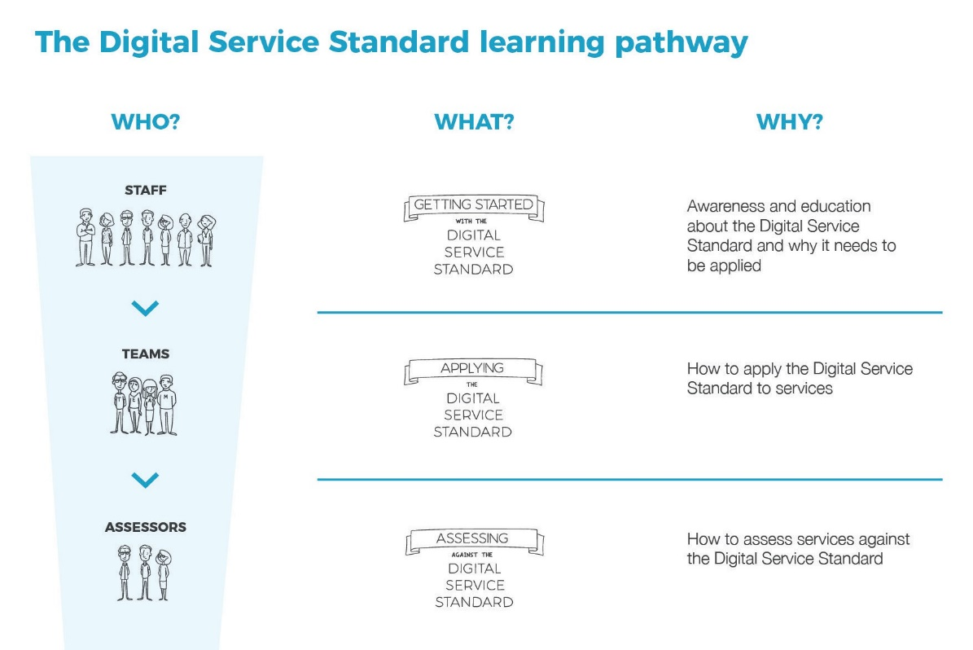

In addition to this training, the DTA is working to build whole-of- government digital capability. Advice on other programs and guidance can be found at [www.dta.gov.au](https://www.dta.gov.au/).

##### What’s included?

This course has been designed to be used by government agencies to build internal capability. All course materials have been pre-prepared, however agencies may choose to build upon or adapt materials to suit agency needs. As part of this training, agencies receive:

* ‘Getting started’ facilitator guide
* ‘Getting started’ slide deck
* videos:
  + ‘Getting started’ video
  + 5 graphic scribe videos (Foundations, Users, Adaptability, Design and Simplicity)
  + captions and transcript files for DTA-owned videos
  + additional videos (third-party owned, see copyright information for details)
* 6 handouts
* the Digital Service Standard poster
* the Service Design and Delivery Process poster
* DTA culture posters

The DTA does not provide print copies of any resources. You will need to organise your own printing based on your agency preferences and participant numbers.

### Delivering the course

##### Course structure

Each module follows a similar structure:

* participants watch a graphic scribe video
* the facilitator guides a discussion on the contents of the video and it’s relationship to the Standard
* participants complete activities to review their mindset (thinking habits) and improve skills to support their understanding of the Standard.

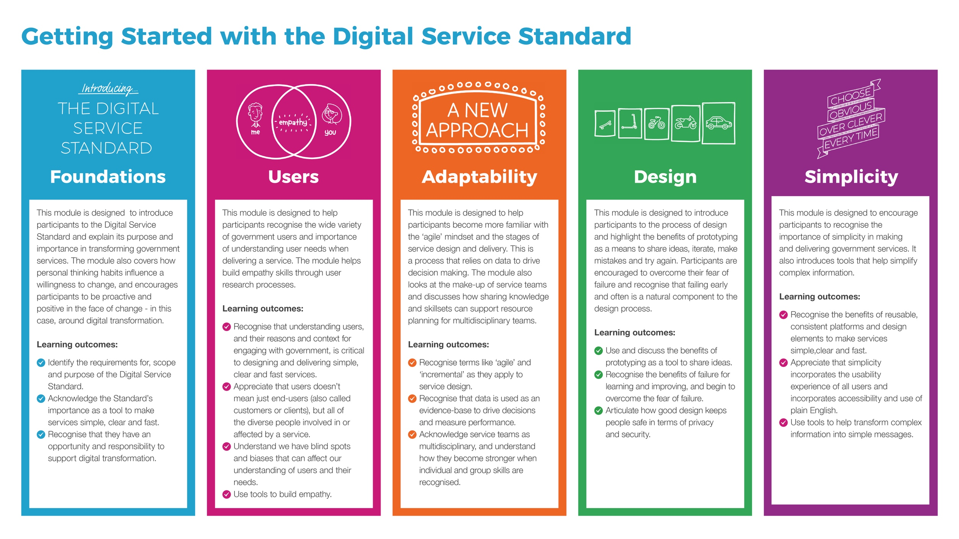



##### Delivery methods

This training is designed to be delivered as a highly interactive, discussion-based face-to-face program. Each module includes a range of activities which encourage participation.

This facilitator guide has been structured to provide example content to be spoken, advice on how to run activities and tips on delivery or related content. As a facilitator, you will need to use your best judgment to guide the discussions and encourage participation. The text and example questions do not have to be followed explicitly, rather they are given as prompts to support the training.

Facilitators should develop and insert ice-breakers, refreshers and energisers into the training to make it more interesting and to suit their facilitation style. Likewise, the use of agency-specific or personal anecdotes is encouraged to make the training more interactive.

Facilitators are encouraged to consider issues such as room layout, the use of subject matter experts, audience make-up and access to technology as a way of better engaging and encouraging participants. Adult Learning Australia1 has published a basic summary of adult learning principles that you might like to review before facilitating this course, especially if you don’t have a background in training adults.

We encourage you to bring your own facilitation experience to delivering this training. If you develop any interesting activities or ideas, please share them with us at [standard@digital.gov.au](mailto:standard@digital.gov.au) as part of our continuous improvement of the training.

##### Agency considerations

Agencies are able to build upon the course content to put it in context and match it up to the organisation’s role, purpose and priorities.

Agencies may also elect to deliver all, or portions, of this course through other methods, such as e-Learning, self-paced learning or blended approaches. In such cases, you should check guidance on copyright and ask for extra support from the DTA before making changes.

##### The ideal facilitator

The ideal facilitator for this course is a person that has both experience and/or qualifications in adult education or learning and development, along with a basic knowledge of the Digital Service Standard (which can

1 https://ala.asn.au/adult-learning/the-principles-of-adult-learning/ 9

be obtained with a good review of the DTA website: <https://www.dta.gov.au/standard/>, by attending a train-the-trainer session for this course or through working in a service team).

The ideal facilitator may:

* hold a certificate IV in Training and Assessment or other adult education qualification
* have experience delivering training in government and/or corporate settings
* have strong communication and interpersonal skills
* be comfortable delivering training to groups.

This list is not restrictive. We would encourage anyone with appropriate skills and knowledge who is interested in facilitating to run this course. The facilitator guide content has been written in a highly detailed manner, with tips and guidance on where to find additional support.

An agency may elect to run this training with co-facilitators, with 1 person from a learning and development area and 1 person from a digital transformation team or subject matter expert (if required, until such time as a single facilitator develops the relevant knowledge

or skills).

##### Train-the-trainer

The DTA will be running train-the-trainer sessions for government agencies to support their implementation of the program. Check the DTA website for details on upcoming sessions. Attendance at the train-the- trainer sessions prior to delivering the training is optional.

##### Involving subject matter experts (SMEs)

A SME is someone who has a deep level of knowledge and experience in a particular area. Using an SME in your training can enrich the participant experience. Consider whether you have access to SMEs who can be involved in parts of your training. For example, you might have access to a User Researcher who could attend the ‘Users’ module, or an Agile Coach who could contribute to the module on ‘Adaptability’.

An example of a SME for this training might be someone that has applied the Digital Service Standard against services, a trained Digital Service Standard assessor, or a member of a digital transformation

team. At the beginning of each module, we have listed some suggested examples of SMEs that may be relevant to that module.

If you do decide to invite a SME, make sure that you take the time to meet with them before the training to discuss your objective in having them attend. Are they there to co-facilitate with you? To share an anecdote during the module? To assist in group work? It is a good idea to define this beforehand. You should also allow them to familiarise themselves with the material for the module.

The use of SMEs to co-facilitate or support training delivery is optional. The course can also be delivered by one person.

##### Sensitive topics

Due to the nature of the mindset activities within each module, where participants are encouraged to reflect on their personal values and behaviours, there is a likelihood of wide ranging views and debates. Ensure participants act with respect and use the facilitator guide to keep discussions on topic. For some some activities, there is not necessarily a “right” or “wrong” answer, but where there is a DTA-preferred approach, this will be specified.

Additionally, the implementation of the Standard and wider digital transformation agenda may be a cause of concern for participants facing change fatigue, low levels of resilience, or those who see it challenging previous ways of working. While this training program alone will not be sufficient to change attitudes and behaviours, it has been designed to support such change. Agencies are encouraged to consider how this training can become part of wider agency-efforts to meet the digital transformation agenda.

##### Timing

The total length of this training, when delivered face to face, is approximately 5 hours. The breakdown of each module is as follows:

|  |  |
| --- | --- |
| **Module** | **Suggested delivery time** |
| Foundations | 70-90 minutes |
| Themes (Users, Adaptability, Design and Simplicity) | 40-60 minutes |

The modules are best delivered in the order established in the training slide deck but you can adapt the sequence to suit your needs. The DTA recommends always beginning the training with the Foundations module.

The training can be delivered in 1 part-day or modularised to suit the facilitator’s availability. Some delivery suggestions include:

* Delivering the training in 1 part or full-day (e.g. 9.00am - 3.00pm with a 1 hour break).
* Spreading the training over 2 days (e.g. 2.00pm - 5.00pm with a 30 minute break).
* Delivering 1 module each week over 5 weeks.

##### Participant numbers

Optimum participant numbers for face to face delivery of this course is recommended at:

* minimum: 12
* maximum: 25

Less than 12 often means that there is not enough participants for engaging group work and debate, and any more than 25 can mean that the group is too large for you to facilitate effectively. Agencies may have slightly higher or lower thresholds, this is a recommendation only.

##### Room set-up

The recommended room layout for delivering this training is in a cabaret style to encourage interaction and group work among the participants.

Less ideal but still acceptable set-ups also include u-shaped and classroom.

The training relies upon the use of videos and presentations, so sufficient

access to audio-visual equipment is required.

Participants should be encouraged to take notes – they may choose to bring a laptop or tablet, so consider any appropriate safety requirements such as power cords and sufficient space to move around the room.

##### List of resources

In order to run the training face to face, you will require:

* audio-visual equipment (e.g. screens, projectors or televisions)
* a computer from which to run the slides/presentations
* course handouts and posters

Additional resources which may be helpful include:

* pens, textas, markers
* post-it notes
* butchers paper or whiteboards
* blue tack

A list of resources required per module and session is detailed in the beginning of each module. The facilitator should carefully check they are properly prepared for each module.

##### Accessibility

The materials within the ‘Getting started’ course are commonly provided in multiple formats or in a Web Content Accessibility Guidelines version

2.0 (WCAG 2.0) compliant format. Videos developed by the DTA within

this program have captions and transcripts.

Facilitators should check with participants prior to course delivery to determine whether anyone has special access requirements and use accessible versions as appropriate.

**After the course**

##### Training evaluation

You are encouraged to regularly evaluate training delivery and content. A template evaluation form is provided for your optional use, or your agency may elect to use internal evaluation processes.

The DTA will be conducting quarterly surveys with agencies delivering the training to determine overall outcomes and make continuous improvement. Agencies will be asked to report on:

* The number of times they have delivered the course.
* The number of people who have completed the training.
* High level ratings of perceived usefulness of the training.
* Comments, questions or suggestions for improvements.

Agencies may also be asked to participate in informal reviews to assist us in continually improving the materials and content.

### Copyright

The intended use of this program is for government agencies to build internal capability. Additional use by third parties is also acceptable, however, this program is not to be resold to government agencies under any circumstances.



© Commonwealth of Australia (Digital Transformation Agency) 2017

With exception of the Commonwealth Coat of Arms and where otherwise noted, all material presented within this training package is provided under a Creative Commons Attribution - NonCommercial (version 4.0) licence.

For details on the licence, see: <https://creativecommons.org/licenses/by-nc/4.0/legalcode>.

##### Attribution

The Digital Transformation Agency acknowledges the work of third parties. Copyright of these videos remain solely with the owner(s):

1. Mark Foden. (2013, June 18). The Gubbins of Government [video file]. Retrieved from [https://www.youtube.com/watch?v=02 3UTqXmU](https://www.youtube.com/watch?v=02__3UTqXmU) Portions of the Foundations graphic scribe video are inspired by the Gubbins of Government video from Mark Foden (2014).
2. Linkedin. (2013, August 12). Linkedin Speaker Series: Fred Kofman [video file]. Retrieved from <https://www.youtube.com/watch?v=IdMvWLARF1w>.
3. Daniel Simons. (2010, April 28). The Monkey Business Illusion by Daniel Simons [video file]. Retrieved from [https://www.youtube.com/ watch?v=IGQmdoK_ZfY](https://www.youtube.com/watch?v=IGQmdoK_ZfY).
4. Derek Silvers. (2010 February 11). First Follower: Leadership Lessons from Dancing Guy [video file]. Retrieved from [https://www.youtube. com/watch?v=fW8amMCVAJQ](https://www.youtube.com/watch?v=fW8amMCVAJQ).

### Where to get help

Comments and questions on implementation of the Digital Service Standard within the agency may be best initially handled by the agency’s digital transformation team or equivalent area.

When in doubt, or for questions and suggestions on training on the Digital Service Standard, contact the DTA via [standard@digital.gov.au](mailto:standard@digital.gov.au).

# Foundations

###### 75 – 90 mins Slides: 1-19

 **Supplies:** audio-visual equipment, pens, paper

 **Artefacts:** Digital Service Standard poster, handouts 1, 2 and 3

**What’s this module about?**

This module is designed to introduce participants to the Digital Service Standard and explain its purpose and importance in transforming government services. The module also covers how personal thinking habits influence a willingness to change, and encourages participants to be proactive and positive in the face of change - in this case, around digital transformation.

##### Learning outcomes

At the end of this module, participants should be able to:

1. Identify the requirements for, scope and purpose of the Digital Service Standard.
2. Acknowledge the Standard’s importance as a tool to make services simple, clear and fast.
3. Recognise that they have an opportunity and responsibility to support digital transformation.

##### Invite a Subject Matter Expert (SME) along

Subject matter experts (SMEs) can enrich the learning experience for participants through sharing their ideas and experience. Where possible, invite a SME to co-facilitate modules. Experts with the following experience are likely to add value to this module:

* members of digital transformation teams
* members of service delivery teams
* agile coaches
* cultural change agents

### Session 1: Welcome

 **5 mins Slides:** 1– 6

Welcome participants and outline agenda. Ask about participants’ roles and awareness of digital transformation, the Digital Service Standard or the Digital Transformation Agency.

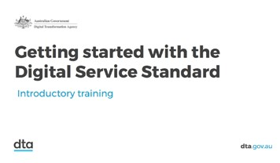

***Conduct an ice-breaker activity. An example is asking participants to share their name, where they work, and if they had a superpower to improve government, what would it be. This encourages participants to think about what improvements they would like to see in government, which aligns to the purpose of this module.***

This course, Getting started with the Digital Service Standard, is an introduction to digital transformation and your role in making better government services. If you’re not familiar with the terms ‘digital transformation’, ‘government services’ or ‘the Digital Service Standard’, you should be after this course.

Today is part of a suite of training on the Standard, which includes 3 courses.

Course 1 – Getting started with the Digital Service Standard

This course is for government employees who need a basic awareness of the Standard. You may be working alongside service teams (for example, in a communication, policy or support role), or have recently begun your journey in digital transformation.

Course 2 – Applying the Standard

This course is for service teams who need to know how to meet the 13 criteria across all aspects of their role.

Course 3 – Assessing Against the Standard

This program is for highly experienced digital professionals to peer- review, mentor and support service teams to help make sure you are meeting the Standard.

Today’s course, ‘Getting started’, is not to turn you into technical specialists or experts, but rather help you become familiar with the Standard and how it applies to you in your role, as well as to the roles of your colleagues. If you’re interested in a role in service design and

delivery, or you’re already building digital services, you might like to attend more training or seek out job opportunities.

**Tip:** See guidance in the Welcome chapter for advice on flexible

delivery models.

This course has a highly flexible delivery model and is made up of

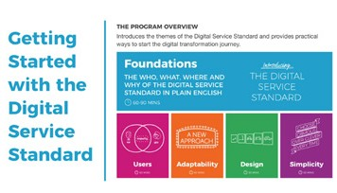

5 modules.

Module 1 is called Foundations. This is a prerequisite to the other 4 modules, which can be attended in any order. Each module goes for about 1 hour, so over a short amount of time you should be able to complete the whole course.

This course is discussion-based; we are interested in your thoughts and opinions so you’re encouraged to participate, to ask questions and to reflect on what your peers contribute too.

### Session 2: Defining the Standard and services

 **20 mins Slides:** 7 – 10

 **Artefacts:** Digital Service Standard poster

Facilitate a discussion with participants across the following questions. Progress through slides giving time for participants to share their perspectives. Encourage participants to review a copy of the Digital Service Standard poster to support their understanding.

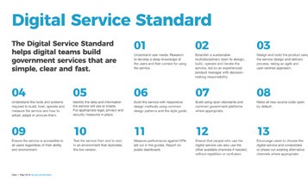

* + Who is familiar with the Digital Service Standard?
  + What is it?

The Standard is a set of broadly applicable, best practice principles for working and making government services. It’s not a checklist.

* + Why do we have a Digital Service Standard?

We’re not focused on building better apps or websites (though better websites will hopefully be a tangible outcome of meeting the Standard). Instead, our intent is changing the way we work, to make better services.

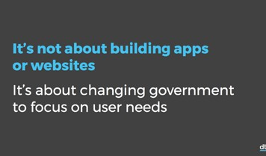

* + What is a service?

Services are things that help people get things done. As the UK Government Digital Service says, ‘services are verbs, not nouns’.

An example of a service is lodging your tax return. The MyTax application is not a service; it’s a technology. You might lodge your tax return using technology like MyTax or you might see a tax agent. The service itself doesn’t change - though the method of delivery and process may

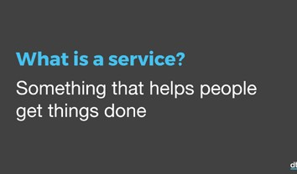

vary slightly.

The Digital Service Standard then, describes how the service should work, not just the technology. (You might think then the name, Digital Service Standard is a misnomer, as some services are not digital. This would be a fair statement. The Standard itself reminds team to consider the non-digital experience – this still might be users’ preferred option

or the only option – but as more services move increasingly online, the name generally works well.)

Ask participants to name other services, for example ones that their agency is responsible for. Write these up on a whiteboard as they are called out. Check for understanding at this point; if participants identify names of technologies or tools, reiterate the service is the level where people are seeking to achieve a task.

Other service examples include registering the birth of your baby,

starting a business, or finding out the weather.

A good government service is one that’s simple, clear and fast.

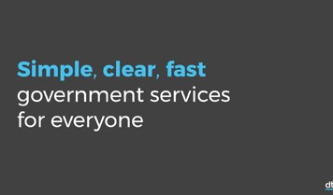

We can’t guarantee that people will always be happy with the outcome of a service (you might not get a big tax return), but we should be able to ensure the service works and is simple, clear and fast.

Because if it isn’t, people won’t use it; they’ll shift channels and become frustrated. And if it’s really bad, they’ll let their friends and family, elected representatives and/or the media, and then we’ll spend a good deal

of time and money fixing something that probably could have been delivered better the first time.

But make no mistake: this isn’t easy. We’re talking about transforming the way government - not just people who work in IT, but all of us - work. And it’s going to take time and dedication. Let’s explore some more reasons why we’re on this transformation journey, and why we’re trying to meet the Digital Service Standard at all.

### Session 3: Commitment and intent

 **10 mins Slides:** 11– 13

Play ‘Getting started’ film. Afterwards, encourage discussion on the themes presented in the video. Clarify any points of contention and check understanding.



* + What did what did you hear, what stood out for you?
  + Did any messages connect to your values or beliefs about what it means to work for the government?

Many of us work on services, or support teams that make services. But not all of those services are in scope to meet the Digital Service Standard. That doesn’t mean they cannot, or should not, meet the Standard, only that they are not technically required to meet it.

The government committed that all Public Governance, Performance and Accountability (PGPA) Act agencies need to meet the Standard for public-facing services, from May 2016.

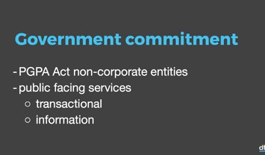

Public-facing services are categorised as transactional, meaning they change records held by government; or informative, meaning they give you information or data, but no changes to records are made.

**Tip:** Find out more information about the scope and mandate for the Digital Service Standard at <https://www.dta.gov.au/standard/>.

The Standard must be applied when you’re building a new, or redeveloping or redesigning an existing service. We do not need to retrofit services, but as it naturally comes to being updated or reworked, we would expect it to apply and demonstrate that it meets the Standard.

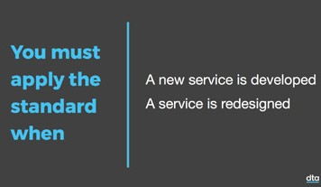

Let’s watch a short video that explains the Standard a bit further.

### Session 4: Graphic scribe video

 **15 mins Slides:** 14– 16

Play the graphic scribe video and then facilitate a conversation about what messages stood out to the audience.

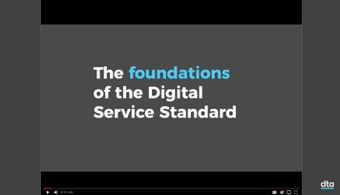

* + What are your thoughts, what did you hear?
  + What was surprising?

**Tip:** Select a point or 2 from the video to help lead a discussion about issues relevant to your agency. See the appendix for video transcripts.

Summarise key messages heard throughout the discussion. If not already raised, add the following points:

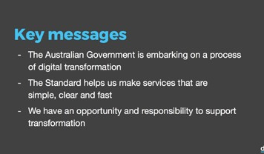

* + The Australian Government is embarking on a process of digital transformation.
  + The Standard helps us make services that are simple, clear and fast.
  + We have an opportunity and responsibility to support transformation.

The intent of this training is not to explore the 13 criteria of the Standard in great detail, but rather consider them through the Standard’s 4 themes (users, adaptability, design and simplicity). Great services come from:

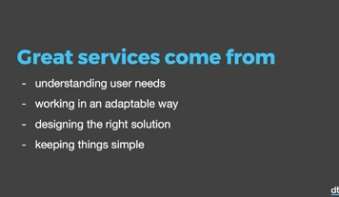

* + understanding user needs
  + working in an adaptable way
  + designing the right solution
  + keeping things simple

We’re going to explore these 4 themes in more detail throughout the day. Before we get there though, we need to consider how our own thinking habits contribute to or restrict our willingness to change.

### Session 5: Mind your mindset

 **30 mins Slides:** 17-18

 **Supplies:** pens, paper

 **Artefacts:** handouts 1, 2 and 3

This new way of working means we need to examine not just what we do, but also how we do it. How we do that starts with our mindset. So next we’re going to talk about developing a particular type of mindset that can really help us change the way we work. Let’s hear author and leadership coach, Dr. Fred Kofman, talk more about it in this video from the LinkedIn Speaker Series.

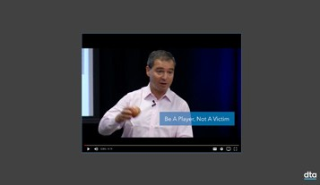

Play Fred Kofman video. Afterwards, facilitate a discussion, choosing from the following example questions.

* + What did you hear? What is Fred Kofman talking about?
  + What are some other word or names you could use to describe a ‘victim’ mindset? How else could you describe a ‘player’ mindset?
  + How would adopting a ‘player’ mindset help us when we’re dealing with a lot of changes at work?

**Tip:** Fred Kofman uses the terms ‘victim’ and ‘player’. However, if you don’t like those words, you could also think about them as:

* a fixed mindset and a growth mindset, or
* a passive mindset and an active mindset, or
* thinking habits that focus on blame, excuses, denial and thinking habits that focus on ownership, accountability and responsibility

To explore the 2 mindsets in more detail, we’re going to do an activity. I’m going to read you a case study about a particularly challenging day someone’s had at work and when I’ve finished, you’ll answer some questions by applying the victim, then the player mindset to the situation. The case study is imaginary - but it’s full of elements we can also all relate to.



Hand out copies of the case study (artefact 2) so participants can

***read along. Read activity to group, then handout the worksheet (artefact 3) to reduce risk the participants will be distracted and not listen to the case study as closely.***

Now that you’ve heard the case study, start on the left hand side of the worksheet and answer the questions using a victim mindset. Imagine you are the person in the case study and those things happened to you. Using a victim mindset, list all the ways you were wronged in the story so that it’s not your fault and you are innocent.

**Tip:** Prompt the group with your own examples, exaggerating issues to help participants recognise the victim mindset.

Once you’ve finished thinking like a victim, move over to the right hand side of the worksheet and start thinking like a player. Go through the same process of answering the questions while imagining you are the person in the case study, only this time, take ownership, accountability and responsibility for the outcomes in the story. As the player, you are proactive, you are solution-focused and self-aware.

**Tip:** When debriefing the victim mindset, make as many excuses as you can to make sure nothing is the victim’s responsibility and that everyone else is to blame – the point is to highlight the flaws in this thinking style. Similarly, when you debrief the player mindset,

challenge participants to take on as much responsibility as they can. Thinking like a player is harder than thinking like a victim, so stay with the questions and press the participants to be as proactive and creative as they can to work out what more they could have done to prevent their problems from occurring.

When participants have completed both sides of the worksheet, debrief the activity by discussing the questions on both sides of the worksheet.

For the victim or the player, the situation is the same. The only difference

is how they have perceived the events.

* Can you think of a time when you (or a colleague or friend) have had a victim mindset? What happened? What would you do differently if you could go back and think about the same situation as a player?
* Can you think of a time when you have had a player mindset? How did your mindset influence the outcome? What did you learn from the situation?
* What would be different in your role if everyone around you was more

of a player?

* When you consider change occurring in your agency, for example, being asked to meet the Digital Service Standard, have you considered how you are going to approach the task?
* After completing this activity, do you think you’ll be more likely to consider your mindset as a choice?
* How will being more of a player help you personally in meeting the the Digital Service Standard?
* What is one thing you can do, starting today, to be more of a player in challenging situation you’re facing right now?

**Tip:** The intent of this debrief is for participants to recognise their responsibility in choosing a response to change. Reluctance to change is a very normal human behaviour, but remaining in a fixed or victim mindset is likely to result in low morale and resilience levels across staff.

The DTA have developed culture posters to support positive messages about change and personal accountability. These are available online at: [https://www.dta.gov.au/files/dta-culture-posters-](https://www.dta.gov.au/files/dta-culture-posters-wcag.pdf) [wcag.pdf](https://www.dta.gov.au/files/dta-culture-posters-wcag.pdf).

Within each theme, facilitate a conversation where the participants use the victim/player mindset roleplaying to identify barriers and solutions to meeting the Standard or implementing a theme. Like in the last activity, encourage participants to think deeply about the problems and solutions, including their role to play.

***Ask participants to identify barriers to meet the Standard using a victim mindset. Write their ideas on the whiteboard. Typical responses might be ‘it’s too hard to change technology, it’ll cost too much money, users just need to learn how to use my service it’s their fault’. Then challenge participants to overcome those challenges with a player mindset, giving them ideas about how they can refute the victim mindset claims.***

***Example solutions might include we’ve already started working in multidisciplinary teams,***

***‘I can seek commitment from our leaders, I can use evidence to prove it works’.***

***The goal of this task is to help participants recognise that some barriers to meeting the Standard are based on negative self- talk and can be improved with a positive, proactive approach.***

***This activity does not mean to imply that the task of meeting the Standard is not complex and without significant challenge, only that it’s possible and can be done with committed people working together and sharing solutions.***

***Share the ‘mind your mindset’ worksheet (artefact 1) to review the types of behaviours that show up with the two different mindsets. Encourage participants to take back to their teams as a reminder about how their choices and thinking habits can affect behaviour.***

**Session 6: What’s next**

 **10 mins Slide:** 19

In this module:

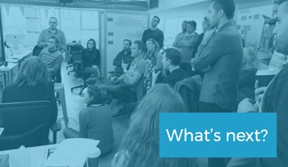

* + We’ve explored what the Standard is: a set of best practice principles that help government agencies make better services.
  + We’ve learned about the government’s commitment to and the scope of the Standard.
  + We heard from colleagues across government about why the Standard exists.
  + We’ve looked at our own mindsets as an opportunity or challenge to embrace the change that digital transformation brings.

Ask participants to identify next steps they could take to keep learning about the Standard and related topics. If a subject matter expert is present, ask their views on useful next steps too, or select from the following prompts:

Following this session, if you would like to learn more about the Digital Service Standard, or topics within this session, you can:

* Review the DTA website and associated guidance, in particular the Standard: <https://www.dta.gov.au/standard/>.
* Take a ‘10 week challenge’ to apply a design principle to the way you work - 1 per week, see: [https://www.dta.gov.au/standard/design- principles/](https://www.dta.gov.au/standard/design-principles/).
* Join a community of practice, for example: [https://www.dta.gov.au/ what-we-do/partnerships/communities/](https://www.dta.gov.au/what-we-do/partnerships/communities/).
* Do more subject-specific or DTA training.
* Seek advice from mentors, digital champions or subject matter experts within the agency about next steps.
* Within the agency, ask to be part of a service team.

Seek for any questions or comments before moving on to the next module.

**Tip:** If delivering training across multiple days, ensure you recap and check learning prior to moving to next theme.

# Users

 **40 – 60 mins Slides:** 20-60

 **Supplies:** audio-visual equipment, whiteboard, pens, paper

 **Artefacts:** Digital Service Standard poster, handouts 4 and 5

### What’s this module about?

This module is designed to help participants recognise the wide variety of government users and importance of understanding user needs when delivering a service. The module helps build empathy skills through user research processes.

##### Learning outcomes

At the end of this module, participants should be able to:

1. Recognise that understanding users, and their reasons and context for engaging with government, is critical to designing and delivering simple, clear and fast services.
2. Appreciate that users doesn’t mean just end-users (also called customers or clients), but all of the diverse people involved in or affected by a service.
3. Understand we have blind spots and biases that can affect our

understanding of users and their needs.

1. Use tools to build empathy.

##### Invite a Subject Matter Expert (SME) along

Subject matter experts (SMEs) can enrich the learning experience for participants through sharing their ideas and experience. Where possible, invite a SME to co-facilitate modules. Experts with the following experience are likely to add value to this module:

* user researchers
* designers
* members of service delivery teams

### Session 1: Graphic scribe video

 **20 mins Slides:** 20-22

 **Artefacts:** Digital Service Standard poster

Ask participants about their users, who the users are, and how their agency interacts with those users. Find out if any formal user research is undertaken in the agency. If so, refer participants back to this area at the end of the module in the ‘what’s next’ session.

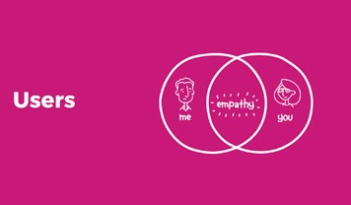

**Tip:** If needed, prompt participants on user groups: colleagues, industry peers and partners, other agencies, members of the public. Even staff in policy and project roles have users – the people who rely on or use their policy are considered users. Other names for users are stakeholders, partners, peers, customers, clients, citizens or most broadly, people.

Play the graphic scribe video and then facilitate a conversation about what messages stood out to the audience.

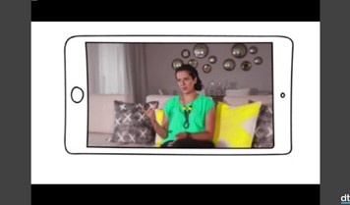

* + What are your thoughts, what did you hear?
  + What was surprising?

**Tip:** Select a point or 2 from the video to help lead a discussion about issues relevant to your agency. See the appendix for

video transcripts.

Summarise key messages heard throughout the discussion. If not already raised, add the following points:

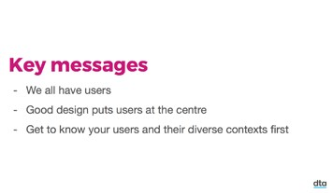

* + We all have users.
  + Good design puts users at the centre.
  + Get to know your users and their diverse contexts first.

Refer participants to the Digital Service Standard poster and seek their ideas about which criteria strongly relate to the theme of users. Encourage participants to share their reasoning with other participants. In fact, most of the criteria relate to most of the themes, but some are more obvious than others. Especially relevant

***criteria applicable to the theme of users includes: 1, 3, 5, 6, 9, 12***

***and 13.***

**Tip:** Become familiar with the Digital Service Standard and read through the details linked to each criterion. Having a solid

understanding of the criteria will help you facilitate discussion. See: <https://www.dta.gov.au/standard/>.

Ask participants to identify barriers to understanding users using a victim mindset. Write their ideas on the whiteboard. Typical responses might be ‘it’ll cost too much money’, ‘we’re not allowed to talk to users’, ‘we don’t have any user researchers’.

***Then challenge participants to overcome those challenges with a player mindset, giving them ideas about how they can turn around the victim mindset claims. Invited subject matter experts may also have good solutions to offer at this point. Be sure to encourage participants to identify solutions as this can help with their recognition of personal accountability in the face of change.***

***Thank participants for their contributions and move into the next session.***

**Session 2: Challenges in getting to know users**

 **10 mins Slide:** 23

**Tip:** Do not prime, give context or advice on ‘The Monkey Business Illusion’ video as this affects how people watch it. For the best result, play the video without much introduction and save all discussion/ context until afterward.

Play the video. Afterwards, facilitate a discussion about how the video relates to users by asking questions:



* + Who saw/did you see the gorilla?
  + If you didn’t see the gorilla, what were you focussing on? If you did see the gorilla, did you notice all the other changes?
* Can you think of another time or experience where you missed something obvious in your environment because you weren’t paying attention or you were focusing on something else?
* The video makes the point that focusing on one thing means we miss out on other important information. How is this relevant when it comes to being ‘user centred’ and understanding our users?

When we talk about getting to know or understand users, we all have pre-existing focus areas or mental shortcuts which come from our own personal beliefs and ideas about who our users are, what they think and feel or what they need.

These mental shortcuts confirm what we already believe. In other words, mental shortcuts can make it difficult for us to notice, see, hear and feel what’s really there, as opposed to what we think, believe or assume is there. We all have stereotypes and biases that we apply to everyone around us. They’re part of life, but that doesn’t mean we can’t broaden our perspectives to let more information in.

User-centred design is about understanding your users and their needs from their points of view – not imposing your beliefs and points of view about what they need, or how they should think, feel or act on them.

* If we’re not focussing on users, what organisational, team and personal priorities might we be focussing on instead? (examples might include costs, efficiency, reputations, KPIs).
* What other biases or mental shortcuts might we be making about our users?
* How can we overcome these shortcuts to better understand users?

The next activity gives us a tool to help improve our understanding by asking us to be mindful and focused on the user.

**Tip:** Clarify that the next activity is not designed to make participants expert user researchers, nor does it replace context user research.

Instead, it’s a tool designed to build foundational empathy skills.

### Session 3: Building empathy

 **25 mins Slides:** 24-25

 **Supplies:** pens, paper

 **Artefacts:** handouts 4 and 5

Facilitate a discussion on empathy. If needed, clarify the difference between sympathy (feeling sorry for someone and empathy (understanding someone else’s emotions and perspective).



Using our imagination is a useful tool for working out how people might be feeling, even if we have never felt the same way. We can confirm if we are right or wrong by observing and asking questions.

It’s important to clarify that we are not suggesting we can understand our users by only imagining what they are thinking/feeling/experiencing. User research involves much more than this and includes checking and validating our understanding with users.

However having empathy is both a perspective and a skill everyone can develop to be more user-centred. Having empathy for your users will help you design better solutions for them, so it’s a good skill to develop even if you’re not building services yet.

Building empathy is a technique for counteracting our mental shortcuts and biases, because you need to pause and really notice what’s going on for the other person – not just focus on what is obvious or what you already believe.

Handout Monty’s story (artefact 4) and the empathy map template (artefact 5), then read the story to the group. Following this, in small groups, have participants complete the template. After a few minutes of group work, bring the room back together and share responses. Look for unique impressions and encourage people to share their reasoning.

In small groups (3-5 people) you’re going to fill in the empathy map according to what Monty might would be thinking, feeling, hearing and saying. For the template, start with the top half of the map thinking about Monty’s situation. You are Monty. Consider:

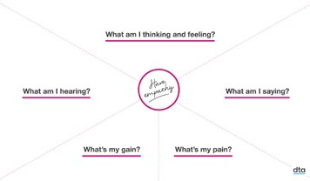

* + What am I thinking and feeling (my thoughts, emotions, physical sensations)?
* What am I hearing? What are friends and family saying? What messages am I picking up from the media or from government messages.
* What am I saying? What am I telling myself and others?

Now move to the bottom questions.

* What is my gain? What are my ultimate goals? (This isn’t about what Monty wants, but rather is his deepest needs).
* What is my pain? What obstacles and frustrations are getting in the way of Monty achieving his goal?

Remind teams that the goal of this activity is not to design a solution to Monty’s problem, it’s about having empathy for Monty to better understand his needs before being able to design solutions.

When participants have completed their empathy map, debrief the activity by facilitating a discussion that works its way around the map, asking these questions:

* How does a tool or a process like empathy mapping help to deepen our understanding of Monty?
* How does having greater empathy for our users help us design better services? How is it more efficient? More productive? More meaningful and satisfying?
* Whose job is it to have empathy for, or understanding of their users?
* Thinking about your own users, how could empathy help you to be more user-centred in everything you do? What would that look like? What difference would it make to your users? What difference would it make to you?
* What’s one small thing you could do to get started and build your empathy muscle starting today?

Anyone can build an understanding of empathy for their users, and I

hope you feel encouraged to do so when you get back in the office.

Today we’re building the foundational skills for user research, the mindset to help you on your journey – but remember user research is a highly specialised skill that often involves years of training and

experience. We don’t expect you to walk out of the room able to conduct

contextual enquiries, but we hope you appreciate the importance of empathy and understanding users when creating and maintaining quality services.

### Session 4: What’s next

###### 5 mins Slide: 26

What have you taken away from this session?



Understanding users is fundamental to making sure you’re delivering high quality service – but it’s not enough. The next 3 modules cover the themes of adaptability, design and simplicity, all equally important to the creation of great services.

If you would like to learn more about the discipline of user research, or the theme of users, you can:

* + Review the DTA website and associated guidance, in particular the Standard: <https://www.dta.gov.au/standard/>.
  + Join a community of practice, for example: [https://www.dta.gov.au/ what-we-do/partnerships/communities/](https://www.dta.gov.au/what-we-do/partnerships/communities/).
  + If you’re already working on a service, commit to being involved in upcoming research (even as an observer). Remember, you should be conducting user research throughout all stages of the service (discovery, alpha, beta, live), so there should be opportunity.

**Tip:** This is a good place to introduce people from your organisation who are user researchers to add some agency-specific advice about next steps, or refer back to advice given (where applicable) about what user research is undertaken in your agency.

**Tip:** If delivering training across multiple sessions, ensure you recap and check learning prior to moving to next theme.

# Adaptability

 **40 – 60 mins Slides:** 27-31

 **Supplies:** audio-visual equipment, whiteboard, pens, paper

 **Artefacts:** Digital Service Standard poster, Service Design Delivery Process poster, handout 6

### What’s this module about?

This module is designed to help participants become more familiar with the ‘agile’ mindset and the stages of service design and delivery. This is a process that relies on data to drive decision making. The module also looks at the make-up of service teams and discusses how sharing knowledge and skillsets can support resource planning for multidisciplinary teams.

##### Learning outcomes

At the end of this module, participants should be able to:

1. Recognise terms like ‘agile’ and ‘incremental’ as they apply to service design.
2. Recognise that data is used as an evidence base to drive decisions and measure performance.
3. Acknowledge service teams as multidisciplinary, and understand how they become stronger when individual and group skills

are recognised.

##### Invite a Subject Matter Expert (SME) along

Subject matter experts (SMEs) can enrich the learning experience for participants through sharing their ideas and experience. Where possible, invite a SME to co-facilitate modules. Experts with the following experience are likely to add value to this module:

* agile coaches
* product or delivery managers
* data or analytics specialists
* members of digital transformation teams

### Session 1: Graphic scribe video

 **30 mins Slides:** 27-29

 **Artefacts:** Digital Service Standard poster, Service Design Delivery Process poster

Facilitate a short discussion on agile methods and ask participants to share their experiences.

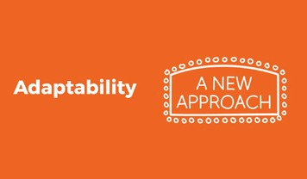

An important component of meeting the Digital Service Standard is ‘being agile’. Who in the room is familiar with agile methodologies, and if so, which do you use? The Digital Service Standard does not prescribe which agile methodology you use, in fact, you may find using a selection of processes and tools best meets your needs.

If confident in doing so, introduce a simple method of tracking progress using a Kanban wall. In this method create three columns on a whiteboard with the titles: ‘to do’, ‘doing’ and ‘done’. Inside the columns, add post-it notes which describe or represent a basic task. The premise of this agile method is that teams use it to track progress against goals.

It helps keep people aware of and accountable to progress. If running all the modules in one day, you might like to record these as tasks, including breaks. For example, add a post it note saying ‘adaptability’ into the ‘doing column’, and add tasks for ‘users’ and ‘foundation’ into the ‘done’ column, with tasks of ‘simplicity’, ‘design’ in the ‘to do’

space. Highlight this as a simple tool participants can take back to their workplace immediately, encouraging them to learn more about Kanban.

**Tip:** Become familiar with some basic agile methods by conducting research. There are a range of methodologies you can look up including the Agile Manifesto, Kanban, Lean, Scrum and more. If a particular methodology is used by your agency, you may like to invite an agile coach to share tips and advice within this module.

Play the graphic scribe video and then facilitate a conversation about what messages stood out to the audience.

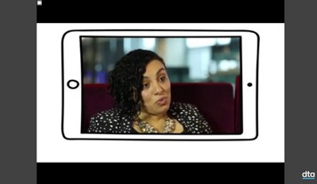

* + What are your thoughts, what did you hear?
  + What was surprising?

**Tip:** Select a point or 2 from the video to help lead a discussion about issues relevant to your agency. See the appendix for

video transcripts.

Summarise key messages heard throughout the discussion. If not already raised, add the following points:

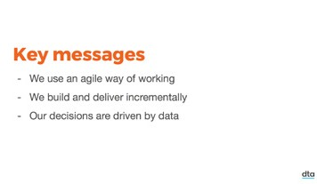

* + We use an agile way of working.
  + We build and deliver incrementally.
  + Our decisions are driven by data.

Refer participants to the Digital Service Standard poster and seek their ideas about which criteria strongly relate to the theme of adaptability. Encourage participants to share their reasoning with other participants. In fact, most of the criteria relate to most of the themes, but some are more obvious than others. Especially relevant criteria applicable to the theme of adaptability includes: 1, 2, 3, 4,

***10, and 11.***

A significant component of the Digital Service Standard and working

in an adaptable way is discussed under criterion 3, which notes that service teams ‘design and build the service using the service design and delivery process, taking an agile and user-centred approach’.

Ask if anyone is familiar with the service design and delivery process, and refer participants to this poster in their handout packs.

As discussed in the video, this is a new approach to designing and delivering services. Instead of beginning with a solution in mind – for example, to create a new website or tool to do X – we begin by identifying a problem or opportunity for improvement.

For example, we might realise we’re facing an increasing number of phone calls to a call centre, or we recognise that parents are not registering their babies on Medicare cards for months after they are

born. Rather than jumping to conclusions about how to fix a perceived problem, we conduct research to identify potential causes. This is called ‘the Discovery stage’.

Guide participants through the Service Design Delivery Process, outlining steps from Discovery through to Live and facilitate a discussion around this. If possible, seek a member from your digital

***transformation team or an SME to share their learnings about this process.***

**Tip:** Become familiar with the Digital Service Standard and read through the details linked to each criterion. Having a solid

understanding of the criteria will help you facilitate discussion. See: <https://www.dta.gov.au/standard/>.

Ask participants to identify barriers to being adaptable using a victim mindset. Write their ideas on the whiteboard. Typical responses might be ‘agile is too risky’, ‘we don’t collect data’, ‘we have to build what’s been announced’.

***Then challenge participants to overcome those challenges with a player mindset, giving them ideas about how they can refute the victim mindset claims. Invited subject matter experts may also have good solutions to offer at this point, but be sure to encourage participants to identify solutions as this can help with their recognition of personal accountability in the face of change.***

***Thank participants for their contributions and move into the next session.***

**Session 2: What’s your T?**

 **10 mins Slide:** 30  **Supplies:** pens, paper  **Artefacts:** handout 6

As shown in the video, a multidisciplinary team allows a flexible and

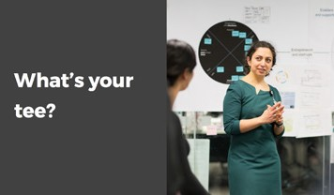

adaptable way of working.

* + What is a multidisciplinary team?
  + What does an ideal team look like?
  + How do you know when you’re in one?
  + How do you know when it’s working well?
  + What’s happening and what does it feel like?

There is no set example of what a multidisciplinary team must look like,

instead, it depends on what skills the team needs to have, based on the likely problems the team will face. For example, a team that needs to undertake a large amount of research early on may start with 2 (or more) user researchers.

A multidisciplinary team has all the specialist skills it needs to research, design, build, operate and measure its outputs. It’s like a Swiss Army Knife, where each team member is one of the tools in the knife, rather than each team member being all of the tools in 1 knife.

A multidisciplinary team has a flexible structure so it can change and adapt at different stages of the process or according to the project or workflow needs.

Now we’re going to talk about ‘t-shaped’ skills. When forming a multidisciplinary team, there needs to be both variety and overlap in each team member’s skills. We call this ideal skillset t-shaped.

What are t-shaped skills? Why are they necessary in a multidisciplinary team?

The types of answers we are looking for are that t-shaped skills describe a person who has deep, expert knowledge and experience in at least 1 particular area (some people may be an expert in more than 1 area) as well as broad knowledge and experience across a range of other areas. People who only have depth, or only breadth, are not t-shaped, but they can improve on this with on the job learning, coaching and training.

People with t-shaped skills are valuable in a multidisciplinary team because they provide depth within their area of expertise and breadth in other areas so they can contribute, collaborate and overlap with other team members.

* Can you identify your own t-shaped skills?
* Can you identify the t-shaped skills of the people in your team, your department, your organisation?

Handout the ‘what’s your T?’ worksheet (handout 6) and in small groups, have participants complete the sheet.

First, choose the 1 or 2 areas you bring the most experience, knowledge and expertise. Put these in the down stroke of the T. As you’ll see on the

worksheet, this is the area you’re able to lead, instruct, advise or mentor others because of your deep knowledge and understanding.

Next, use the cross stroke of the T to fill out your breadth of experience. These are your skills and experience across a broad range of subject areas and disciplines. As you’ll see on the worksheet, these are areas you’re able to contribute or collaborate with as a generalist.

When you’ve finished filling out your T, take it in turns to share your depth and breadth of experience with the person next to you, discussing what you enjoy most about working within your skillset in each area

and why.

Debrief the activity and discuss from the following prompt questions:

* If you’re working in a multidisciplinary team, why is it important to know the skills and experience of the people in your team?
* Why is it important to understand what your team mates enjoy doing most and why they enjoy doing it?
* How does being curious about other people’s skills and experience as well as sharing information about yourself/your skills help us to be more agile and adaptable?
* When do you or could you share this kind of information within your team? How could a team make sure it’s getting the most out of each person’s breadth and depth of experience?
* What’s the most likely outcome of utilising team members’ skills and experience in the areas and ways they most enjoy using them?
* What’s one small thing you could do to get started with finding out more about your colleagues’ t-shaped skills and sharing your own starting today?

### Session 4: What’s next

###### 5 mins Slide: 31

What have you taken away from this session?

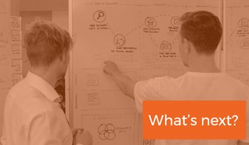

If you would like to learn more about the theme of adaptability, you can:

* + Review the DTA website and associated guidance, in particular the Service Design Delivery Process: [https://www.dta.gov.au/standard](https://www.dta.gov.au/standard/service-design-and-delivery-process/)
  + Undertake agile training.
  + Visit the DTA dashboards to learn more about data collected for service teams: [https://www.dta.gov.au/what-we-do/platforms/ performance/](https://www.dta.gov.au/what-we-do/platforms/performance/).

**Tip:** This is a good place to introduce people from your organisation who are agile coaches, delivery managers or data specialists to

add some agency-specific advice about next steps, or refer back to advice given (where applicable) about what agile training and support is offered in your agency.

**Tip:** If delivering training across multiple sessions, ensure you recap and check learning prior to moving to next theme.

# Design

 **40 – 60 mins Slides:** 32-36

 **Supplies:** audio-visual equipment, whiteboard, pens, paper

 **Artefacts:** Digital Service Standard poster

### What’s this module about?

This module is designed to introduce participants to the process of design and highlight the benefits of prototyping as a means to share ideas, iterate, make mistakes and try again. Participants are encouraged to overcome their fear of failure and recognise that failing early and often is a natural component to the design process.

##### Learning outcomes

At the end of this module, participants should be able to:

1. Use and discuss the benefits of prototyping as a tool to share ideas.
2. Recognise the benefits of failure for learning and improving, and begin

to overcome the fear of failure.

1. Articulate how good design keeps people safe in terms of privacy and security.

##### Invite a Subject Matter Expert (SME) along

Subject matter experts (SMEs) can enrich the learning experience for participants through sharing their ideas and experience. Where possible, invite a SME to co-facilitate modules. Experts with the following experience are likely to add value to this module:

* designers
* agile coaches
* members of service delivery teams

### Session 1: Graphic scribe video

 **20 mins Slides:** 32-34

 **Artefacts:** Digital Service Standard poster

Facilitate a discussion on design, asking participants to define

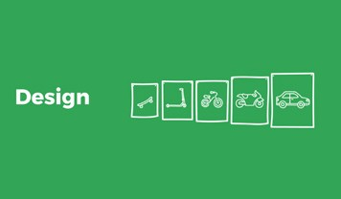

***the term.***

Design, as it relates to the Digital Service Standard, is not simply about how something looks or its visual appeal, but is rather about the

usefulness and functionality of how something works. Designers are not simply creative types or artists (though they can be creative and artistic), they are people who are able to achieve functionality, often in useful, innovative, clear or simple ways.

Design is not just about visual treatment. Multidisciplinary teams include a range of design roles, for example content, interaction and service design.

**Tip:** For descriptions of roles within service teams, see: <https://www.dta.gov.au/standard/design-guides/the-team/>.

Play the graphic scribe video and then facilitate a conversation about what messages stood out to the audience.

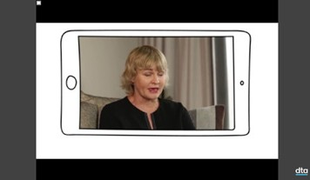

* + What are your thoughts, what did you hear?
  + What was surprising?

**Tip:** Select a point or 2 from the video to help lead a discussion about issues relevant to your agency. See the appendix for video transcripts. If applicable, revisit the definition and ask participants if they have a revised understanding of the term.

Refer participants to the Digital Service Standard poster and seek their ideas about which criteria strongly relate to the theme of design. Encourage participants to share their reasoning with

***other participants. In fact, most of the criteria relate to most of the themes, but some are more obvious than others. Especially relevant criteria applicable to the theme of design includes: 1, 2, 3, 4, 5, 6, 7,***

***9, 10, 11, 12.***

**Tip:** Become familiar with the Digital Service Standard and read through the details linked to each criterion. Having a solid

understanding of the criteria will help you facilitate discussion. See: <https://www.dta.gov.au/standard/>.

Summarise key messages heard throughout the discussion. If not already raised, add the following points:

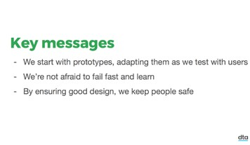

* + We start with prototypes, adapting them as we test with users.
  + We’re not afraid to fail fast and learn.
  + By ensuring good design, we keep people safe.

**Tip:** If possible, arrange for a subject matter expert to be available in

the module and ask them to share their thoughts on the film.

Ask participants to identify barriers to applying design using a victim mindset. Write their ideas on the whiteboard. Typical

***responses might be ‘it’ll cost too much money’, ‘we’re not allowed to get it wrong / fail’ or ‘we don’t have designers on our team’.***

***Then challenge participants to overcome those challenges with a player mindset, giving them ideas about how they can challenge the victim mindset claims. Invited subject matter experts may also have good solutions to offer at this point, but be sure to encourage participants to identify solutions as this can help with their recognition of personal accountability in the face of change.***

***Thank participants for their contributions and move into the next session.***

**Session 2: Determining great service**

 **30 mins Slide:** 35

 **Supplies:** pens and paper (use of coloured pens, textas or crayons, and large blank paper is recommended for this session)

As we think more about the ways in which we are all responsible for designing great services (even if design is not your area of expertise), we’re going to do an activity where everyone becomes a designer.

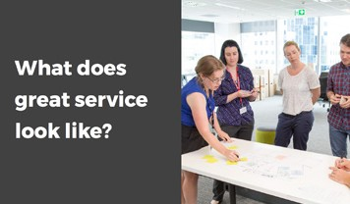

With your pens and paper, draw a picture of a time you experienced a really great service - try to think of the best service you’ve ever

experienced. It can be from your home or work life, it doesn’t need to be government-specific. Remember our earlier discussion on what a service is (e.g. something that helps people achieve a goal, or get something done).

Take some time to think about this service, then draw your recollection of what happened and how it made you feel. In a few minutes, you’ll share your work with the group.

Resist the urge to use words - use pictures only.

Many participants will feel very uncomfortable about having to draw something let alone having to share their work with others, and will resist or choose not to participate. This is a significant point to the activity, so without drawing attention to the discomfort, just encourage people to have a go. Walk through the group to take note of who is struggling with the task. Allow a few minutes for people to complete the task.

Now that you’ve all had time to draw something, you’ve all just had a little taste of working as designers and you’ve created the prototype or a concept for a great service experience.

* How did this activity make you feel?
* When I said you were going to have to draw something, what was the

first thought that went through your mind?

* Who told themselves ‘I can’t draw’ or ‘I don’t do things like this’ or ‘this is stupid’ or ‘I’ll look like an idiot’ or ‘what if I make a mistake’?
* Who got stuck because they were worried about not being able to come up with ‘the best’ service experience? Who couldn’t get started because they were judging their own ideas about what’s ‘the best’? Who got stuck because they felt competitive about coming up with ‘the best’ example? Who got stuck in perfectionism?
* When we have these types of feelings and tell ourselves these types of things – what’s really going on for us? What is it we’re actually worried about and how do they hold us back when we’re coming up with new ideas?

In this discussion, we’re hoping to illustrate that acting outside our comfort zone can bring up a fear of failure.

People often experience fearful and defensive thinking. This is self- protection: no one wants to look silly, to be embarrassed or to damage their reputation – all very understandable and common thoughts.

However, this type of thinking is also the enemy of empathy, creativity, ideation and experimentation – which is where problem solving and new ways of thinking come from.

The design process, iterative working and prototyping are about making continual progress, not nailing perfection.

When it comes to design and getting your ideas out into the world, an activity like drawing or sketching what you’re thinking or imagining or prototyping can be scary, but it can also be very effective.

* Why do you think that is?

Drawing, sketching or prototyping your thoughts in any quick or rough stye is a low-risk way of showing what you’re thinking. It’s fast, it costs nothing, it’s visual, it can be more engaging and emotional than words, numbers, data or very rational representations (like a flow chart or Gant chart) alone. It also creates a model of an experience that you can share and others can discuss, ask questions about and give feedback on – because it engages their imagination too.

Now that we’ve talked about how the activity made you feel (and why it made you feel that way), let’s talk about what you’ve actually drawn and the qualities of the service experiences you’ve captured.

Facilitate a discussion about what the best service looks and feels like by having several participants share their drawings and asking

these questions:

* Who’ll show us their picture and tell us the story about the best service experience?
* Where were you? What happened? Why was it so special? How did it make you feel?

In this discussion, we are aiming to build a picture of what great service looks like and to find common themes across different people’s experiences. The types of common experiences we’re aiming to draw out are that great service is:

* + personalised, tailored, unique to me and my needs, adapted to the situation
  + human, thoughtful, intuitive, respectful, kind
  + quick, easy, obvious, uncomplicated, invisible, available, works

Now that we’ve explored what the best service looks like across a range of different industries and experiences (and what they have in common) why should the government services you design be any different from these? What can we learn from this (and other industries) and how can we use it to make our own services better?

### Session 3: What’s next

###### 5 mins Slide: 36

What have you taken away from this session?



If you would like to learn more about design, you can:

* + Review requirements for government information in more detail, see criterion 5 for links to security and privacy rules among others: <https://www.dta.gov.au/standard/5-make-it-secure/>.
  + Check out the DTA’s UI Kit: <https://github.com/govau/uikit>.
  + Take a ‘10 week challenge’ to apply a design principle to the way you work - 1 per week, see:

<https://www.dta.gov.au/standard/design-principles/>.

* + Start prototyping in your team.
  + If you’re uncomfortable with your visual communication or drawing skills, take a quick class or do some research online about building this skill.

**Tip:** Ask a SME for agency-specific suggestions about design, and

how participants can learn more.

**Tip:** If delivering training across multiple sessions, ensure you recap and check learning prior to moving to next theme.

# Simplicity

 **40 – 60 mins Slides:** 37-41

 **Supplies:** audio-visual equipment, whiteboard, pens, paper, post-it notes

 **Artefacts:** Digital Service Standard poster

### What’s this module about?

This module is designed to encourage participants to recognise the importance of simplicity in making and delivering government services. It also introduces tools that help simplify complex information.

##### Learning outcomes

At the end of this module, participants should be able to:

1. Recognise the benefits of reusable, consistent platforms and design

elements to make services simple, clear and fast.

1. Appreciate that simplicity incorporates the usability experience of all users and incorporates accessibility and use of plain English.
2. Use tools to help transform complex information into simple messages.

##### Invite a Subject Matter Expert (SME) along

Subject matter experts (SMEs) can enrich the learning experience for participants through sharing their ideas and experience. Where possible, invite a SME to co-facilitate modules. Experts with the following experience are likely to add value to this module:

* designers
* accessibility or usability professionals
* agile coaches

### Session 1: Graphic scribe video

 **20 mins Slides:** 37-39

 **Artefacts:** Digital Service Standard poster

If possible, share a personal anecdote about a service, ideally a government service, which could or should have been a lot simpler, but wasn’t. Discuss what happened and how you felt. Alternatively, ask participants about how their dealings are with government, has anyone described the process as simple? The intent of this activity is not to embarrass staff or make people feel like they are doing a poor job. Government is rarely simple, and is often complex for good reason. What we’re trying to illustrate is that often services could be simpler, with some consideration and willingness to try.

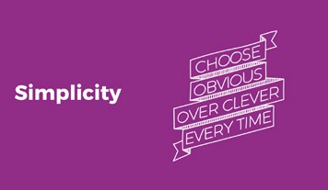

The theme of simplicity is last because in some ways it is the culmination of the other 3 themes: you can understand user needs, design good solutions, work in adaptable ways and still over-engineer a solution or end up spending more than you should. By keeping it simple, we’re better able to be agile, not over-design or miss our user’s actual needs.

Let’s watch the video on simplicity.

Play the graphic scribe video and then facilitate a conversation about what messages stood out to the audience.

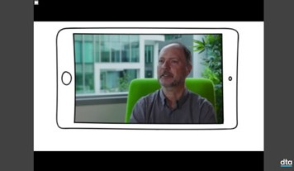

* + What are your thoughts, what did you hear?
  + What was surprising?

**Tip:** If possible, arrange for a subject matter expert to be available in

the module and ask them to share their thoughts on the film.

**Tip:** Select a point or 2 from the video to help lead a discussion about issues relevant to your agency. See the appendix for

video transcripts.

Summarise key messages heard throughout the discussion. If not already raised, add the following points:

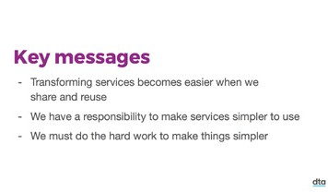

* + Transforming services becomes easier when we share and reuse.
  + We have a responsibility to make services simpler to use.
  + We must do the hard work to make things simpler.

Refer participants to the Digital Service Standard poster and seek their ideas about which criteria strongly relate to the theme of simplicity. Encourage participants to share their reasoning with other participants. In fact, most of the criteria relate to most of the themes, but some are more obvious than others. Especially relevant criteria applicable to the theme of simplicity includes: 1, 3, 4, 6, 7, 8,

***9, 10, 12 and 13.***

**Tip:** Become familiar with the Digital Service Standard and read through the details linked to each criterion. Having a solid

understanding of the criteria will help you facilitate discussion. See: <https://www.dta.gov.au/standard/>.

Ask participants to identify barriers to keeping it simple using a victim mindset. Write their ideas on the whiteboard. Typical

***responses might be ‘managers keep changing my content, they don’t know how to write simply’, ‘more is better, we don’t want to under-deliver’, ‘we’re locked into technology choices; there’s no option to change’.***

***Then challenge participants to overcome those challenges with a player mindset, giving them ideas about how they can turn around the victim mindset claims. Invited subject matter experts may also have good solutions to offer at this point, but be sure to encourage participants to identify solutions as this can help with their recognition of personal accountability in the face of change.***

***Thank participants for their contributions and move into the next session.***

**Session 2: Elevator pitch**

 **20 mins Slide:** 40

 **Supplies:** pens, paper, post-it notes

We’re going to do an activity now that will give you a practical experience of making something complex simple.

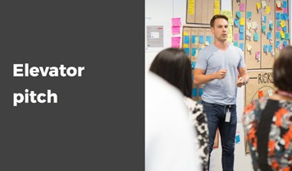

Imagine that tomorrow you’re in the kitchen and you run into a colleague. They ask you about the ‘Getting started’ training you just attended,

and mention they’re not really sure what this Digital Service Standard is all about. They ask you to explain it, but note they only have a few minutes before they need to run to a meeting. You’ll need to keep it simple, without losing too much information or meaning. You know your colleague may not be familiar with some of the terms you heard in training, so you may need to adjust your language.

Finally, you’re keen to share to share more than just what the training was about, so you include to add an anecdote or piece of information that you found novel. This could be from the videos, activities or discussion throughout the day.

Your task is to create an elevator pitch, that is, a short statement that explains a topic quickly and garners support for your cause. You’ll need to include the following things in your pitch:

* 1. a definition or explanation of the Digital Service Standard
  2. reasons why the Standard is important (to your agency, the government, users, or all of the above - it’s up to you)
  3. something interesting you learned in the training

Organise participants into small groups (ideally 2-4 people per group), provide post-it notes or blank paper to build their elevator pitch.

***Allow participants to self-organise and approach the task in their own manner. If they appear to be struggling, add structure by encouraging them to begin with brainstorming prior to refining messages. Discourage evaluation of ideas in the brainstorming stage - it limits creativity and the flow of ideas. Once they have a volume of ideas, these can be grouped into the categories listed above (for example a definition or the Standard, reasons it is important, interesting things learnt).***

***Walk through the group reminding them of messages from earlier modules. What you are looking for is a well-balanced elevator pitch that is neither too long or too short, one that covers all the required topics. Ideally it will convince the colleague or encourage them to learn more.***

***After a few minutes, ask the teams to stop and share their current pitch with another team to gain a critique to help refine their messages. Remind teams to be constructive in their feedback. Write on the whiteboard suggestions for ensuring the pitch is effective, such as:***

* + - think about your audience
    - check your messages flow seamlessly
    - use simpler words, or explain terms
    - check you’ve answered all parts
    - reduce duplication

After teams have shared their pitch and received a critique, give them a few more minutes to make updates. Then, bring all participants back together to share with the larger group. Ask for volunteers to share their pitch – if you like, role-play as the colleague in the kitchen asking about the training.

***Congratulate teams and debrief the session by discussing the approaches they took to refine content to a simple elevator pitch. Promote the fact that many in the room may not have been able to complete that elevator pitch before the training – that is, discussing what the Digital Service Standard is and it’s importance, so a lot has been learnt in a few hours. In order to simplify something, we need to understand it – but we can all benefit from iterating (as discussed in the video under the build, learn, measure cycle).***

**Session 3: What’s next**

 **5 mins Slide:** 41

What have you taken away from this session?

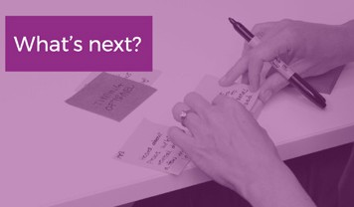

If you would like to learn more about design, you can:

* + - Use online content checking tools to improve the readability of your content.
    - Join a community of practice, for example: [https://www.dta.gov.au/ what-we-do/partnerships/communities/](https://www.dta.gov.au/what-we-do/partnerships/communities/).

# Conclusion

 **15 mins Slides:** 42-48

 **Supplies:** audio-visual equipment

Begin to wrap up the course. Share any anecdotes about the learning or discussions across the day. Thank participants for their engagement and remind them to complete a training evaluation form to help you keep iterating and improving the course.

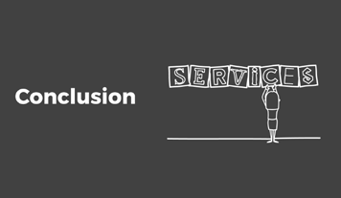

Today we’ve discussed the Digital Service Standard and great services come from:

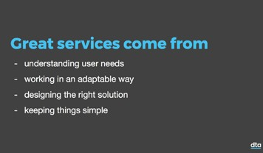

* + - understanding user needs
    - working in an adaptable way
    - designing the right solution, and
    - keeping things simple

You have considered how the Standard’s 13 criteria apply to these 4 themes. I hope you will agree the Standard is not a complex or

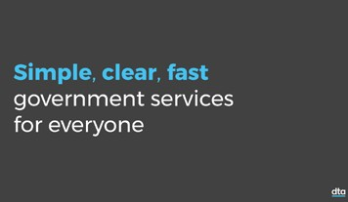

unknowable ICT policy, but rather a set of best practice principles for how we work in making services that are simple, clear and fast. I hope too that you recognise the benefits of better government services,

for our users and our agencies in improving the way we work, finding efficiencies and savings.

This was the introduction to the Digital Service Standard. If you want to learn more you can attend further training, seek coaching or mentoring opportunities from those within the field or join service teams to learn on the job. There are also a large number of external training programs and online guidance about service design, agile delivery, user research and more, so I would encourage you to keep learning developing your

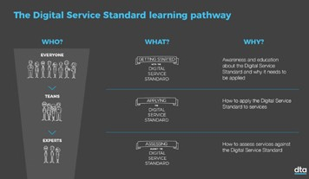

digital capabilities.

We’re going to leave you with one final thought.

Play first follower video.



**Tip:** The first follower video is a tongue-in-cheek evaluation of leadership models and the importance to acknowledge not the leaders (whom typically get the credit) but more so the followers, those that implement the change and propel a movement. It is meant as a light-hearted encouragement to the large groups of people responsible for making better services by understanding and using the Digital Service Standard.

We’re embarking on a process of change, of digital transformation. It’s going to need people that are willing to try and fail, and learn and try again. This is not an easy task but it is an important one. We thank the people – like you – who are the first followers of the Digital Service

Standard, those who are learning about it and beginning to work in new ways, making better services.

Close training with time for any final questions or comments. You may like to point follow up questions to an agency-specific phone number or email.

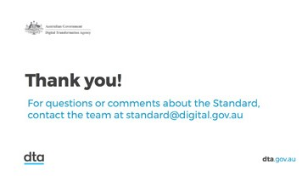

**Appendix**

The following are text alternatives to the DTA branded videos within this training. They can be used as alternatives for participants who require an accessible version, e.g. have a vision or hearing impairment. Facilitators are also encouraged to use these text alternatives to find relevant key messages and opportunities for discussion pertinent to their agency.

**Text alternative for the Getting started video**

DESCRIPTION: The Australian Government Coat of Arms. Black text beneath it reads: Australian Government Digital Transformation Agency. A DTA logo is in lowercase lettering.

The video moves between clips of people being interviewed and people doing everyday tasks, such as working, talking, travelling through an airport, watering their gardens as well as accessing government services like applying for passport or lodging a tax return.

Text: Getting started with the Digital Service Standard.

Text: The Hon Angus Taylor MP. Assistant Minister for Digital Transformation.

ANGUS TAYLOR: We have the opportunity with technology to provide far better services than we have in the past and making it easy is the key.

DESCRIPTION: A man in a wheelchair sits at a laptop computer. He operates his wheelchair by pressing his chin onto a joystick control.

Text: Sean Fitzgerald. Accessibility & Disability Advocate.

SEAN FITZGERALD: Often people with a disability have to interact with government departments a lot and a general way of getting someone to fill in a form is to send it out in the mail. Well it just doesn’t work for people who are paralysed.

Text: Andrew Arch. Accessibility and Inclusivity. Digital Transformation Agency.

ANDREW ARCH: If you don’t have the language skills or the technical skills in terms of being able to use the system the way it’s previously been designed it can make you frustrated.

Text: Nina Amini. Product Management. Digital Transformation Agency.

NINA AMINI: Users shouldn’t have to understand government to deal with government.

Text: Jacqui van Teulingen. Service Standard. Digital Transformation Agency.

JACQUI VAN TEULINGEN: People have no choice with government, so we have this deep moral obligation to make sure that what we’re doing in government everybody can use.

Text: Ole Nielsen. Digital Leader. ACT Government.

OLE NIELSEN: The citizen, they’ve got to get on with their life. So they want whatever they have to do with government to be easy.

ANGUS: The important thing for us is to focus on the opportunities. They are very significant here. Reinventing government and at the heart of that it means a different way of doing government.

DESCRIPTION: Image of the Digital Service Standard poster, panning across text which specify the 13 criteria of the Standard.

JACQUI: We looked all around the world between the private sector, the public sector and we said, “What is best practice in service design and delivery?” So the Standard is a set of principles if you like around how we will design and deliver services.

Text: Rob Webb. Digital Leader. Bureau of Meteorology.

ROB WEBB:Those core principles of building yourself around the user. OLE: A set of really pragmatic guidelines that are grounded in experience

and starts with user first.

Text: The Digital Service Standard is built around four themes.

JACQUI: Users. Design. Simplicity. Adaptability. If we design with users in mind the whole time, be they an end user, a user within the ecosystem of a service, then we get a service that we know will work.

ANDREW: We do need to take the time to think through how we can make things clearer and simpler for them.

ROB: That’s what working in a digital world is going to be. We have to be mindful that life will move on. We have to change our minds.

Text: The Digital Service Standard: changing the way we work.

OLE: It’s about transforming people and how we work. It’s not about technology. It is not the bricks. It is the mortar that matters.

Text: Mark Williams. Digital Transformation. Digital Transformation Agency.

MARK WILLIAMS: No one likes to change. Let’s be honest. It’s hard because it means getting out of your comfort zone. It means looking at problems in a different way. And it means listening to answers that you don’t want to hear.

Text: Daniel Bamford. Digital Leader. Australian Taxation Office.

DANIEL BAMFORD: We already have runs on the board. We actually need to remember that.

ROB: You can stand around and wait for someone else to do it, but part of your role in the Public Service is to stand up and say, “We’re going to do this. This is how we’re going to do it”.

ANGUS: If Australians interact with government and at the end of each of those interactions they say, “That was easy”. I think we’ve had a huge impact.

Text: The Digital Service Standard: helping make services simple, clear, fast.

Sky-blue text reads: Getting started with Digital Service Standard.

Black text reads: Video by the Digital Transformation Agency dta.gov.au.

Production 10 April 2017.

Copyright. Commonwealth of Australia (Digital Transformation Agency) 2017.

With exception of the Commonwealth Coat of Arms and where otherwise noted, all material presented within this training package is provided under a Creative Commons Attribution - NonCommercial (version 4.0) licence.

### Text alternative for the Foundations Video

DESCRIPTION: The Australian Government Coat of Arms. Black text beneath it reads: Australian Government Digital Transformation Agency. A DTA logo is in lowercase lettering.

Black and sky-blue text reads: The foundations of the Digital Service Standard.

NARRATOR: The world is changing, fast. Despite our best intentions, many government services are being left behind.

Text: Introducing the Digital Service Standard. After a short pause, “In Plain English” appears beneath it.

NARRATOR: To make government fit for the 21st century, we’re introducing a new and better way of working. And the Digital Service Standard will be your guide. So here is The Digital Service Standard, in plain English.

DESCRIPTION: Animated image shows a diverse group of people. NARRATOR: Here are some people - Jack, Jill, me, you, my mum, your

dad, the guy who makes your coffee in the morning, your GP and

his grandad.

All of them use government services. Because to get things done, we need to use government services. If they want a holiday in Europe, they’ll need to get a passport. And so on. For some of them, it’s easy. For others, it’s not so easy.

DESCRIPTION: Animated image shows example transactional services like buying a house demonstrated by exchanging house keys, or getting a tax refund. Example informative services are also shown, like finding out the weather or using a map.

NARRATOR: Some services are transactional. Others just give you information to help you make decisions about things. All of them use some IT. We want them to become more digital, because they’re simple, clear and fast. And it’s cheaper.

Services are delivered by government agencies, that’s us, using bits of technology, usually provided by big suppliers, through long-term contracts. It’s expensive. It’s hard to change. And usually, it’s not that great. This is what people tell us, all the time.

It needs to change. And the way we’re going to change it is to make new technology services, delivered over the internet. But we won’t be going it alone. We’ll be doing it together, guided by the Digital Service Standard.

DESCRIPTION: Image shows animated characters, “my mum” and “the guy who makes your coffee” in their day to day lives. The mum animation is about to take her dog for a walk, surrounded by laundry, and the guy who makes coffee is trying to serve coffee to someone whose children are running around the coffee shop.

NARRATOR: Let’s break it down. A service is made up of people, process and technology. When our starting point is people - my mum, the guy who makes your coffee - and understanding what they’re trying to do in their busy lives, we can make a better service.

DESCRIPTION: An animation shows a multidisciplinary team made up of a designer, researcher, developer and product manager sharing a prototype with a user to learn the user needs.

NARRATOR: And we can do it faster if we, that’s us in government, have all the right people with the right skills making the service together, continually checking in with users. This way, we know we’re making the right thing.

DESCRIPTION: An animation shows the different steps of the “Service Design and Delivery Process”. Discovery, Alpha, Beta, Live are written from left to right.

NARRATOR: Then we come to the process part. We spend time learning what people need. Then ask ourselves, “how might we meet that need?”. We build some prototypes and we ask people - my mum and the guy who makes your coffee - to try them out. We learn from how people use our prototypes. And then we build what works best. And start operating the service.

And that brings us to the exciting part - the technology. Let’s make it simple - our services are made up of layers. The first layer is where people interact with us, via a paper form, a telephone call, or commonly,

a website or app. We present information to people on this layer.

If we use words that people understand, they’ll get it. We also need to make sure people can access our services and that they don’t have to tell us the same things over and over, making it easier for people to gets things done.

DESCRIPTION: An animation shows the ‘User Interface’. Speech bubbles with a cross on them read: “I’d like to change my address”, “Could I update my address” and, finally, “My address STILL needs updating…?!!”

NARRATOR: The next layer is where all the service-y things go. These can be service-specific things, like calculating tax. Or it might be something that is used across many services, like making a payment, verifying identity, or making sure things are kept safe and secure. Or they could be machinery kind of things - like sophisticated IT services, databases, storage, mainframes etc.

And as everything becomes more digital, we become able to build services in a modular way, using modular parts, that can be swapped out without affecting other parts. And if we need to, we can buy different parts from different suppliers. Instead of all of it from just one or two.

As we go through each of our services, untangling them, we’ll know what all the common parts are. And then we can borrow those parts from each other. Improving them as we need, or just reusing them.

They cost a lot, so we don’t want to keep on buying the same parts every time we have the same need. By sharing parts, we don’t have to build things from scratch every time. This way, we save more money and we can make new services better, cheaper and faster.

Oh, just one more thing. Making our new services in this way is a big job. We’ve got lots of services and lots of people who use them. If we can stay on top of what’s happening for those people and respond to their needs quickly, then people will have more trust in what we do here

in government.

DESCRIPTION: A speech bubble reads: “Of course Mr Jones, I’ll make sure that’s sorted for you straight away”.

NARRATOR: So as you build new services make sure you tell people -

yep, my mum and the coffee guy - you’ve made a new service. Invite them to try it out and make sure you give them an easy way to let you know if it does the job for them. That way, you’ll be sure to know what’s working and what’s not, so you can continue to make it even better. And pretty soon, more and more people will use the new services. Because they’re simple, clear and fast.

And that, friends, is the Digital Service Standard, in plain English. Try it out and be sure to let us know how you go.

Text: The Digital Service Standard (In Plain English). Digital Service Standard is written in sky-blue text.

Black text reads: Video by the Digital Transformation Agency dta.gov.au.

Copyright. Commonwealth of Australia (Digital Transformation Agency) 2017.

With exception of the Commonwealth Coat of Arms and where otherwise noted, all material presented within this training package is provided under a Creative Commons Attribution - NonCommercial (version 4.0) licence.

Some concepts in this video build upon existing material called ‘Gubbins of Government’ (2014) by Mark Foden, UK (markfoden.com).

### Text alternative for the Users video

DESCRIPTION: The Australian Government Coat of Arms. Black text beneath it reads: Australian Government Digital Transformation Agency. A DTA logo is in lowercase lettering.

Sky-blue text reads: Users.

NARRATOR: We all have to use government services. So to give our users a government experience that‘s fit for the 21st century, we need to make sure that interacting with us is easy and efficient.

To help us do this, we’re introducing a new approach, underpinned by a set of principles called the Digital Service Standard. It’s grounded in user-centred design and puts humans (the people who use and deliver our services) at the centre of everything we do.

The first step is to really get to know who your users are and their

context. And when we say users we mean ALL users.

DESCRIPTION: A graphic animation of Australia appears with lots

of different people’s faces across it. The image fades and another animation shows groups of users, a family, couples, singles, men and women, a person in a wheelchair, an older person, a person travelling, and a person working.

LEISA REICHELT: It’s like looking out a million windows all over the country and seeing the world around you and everybody you walk past is a user with their own story, their own history that makes their experience of dealing with Government unique. Our colleagues in Government are users of the overall service as well. And helping make their experience and their tools better can be the most effective way to improving end-users’ experiences too.

DESCRIPTION: An stylized animation depicts a mother holding a crying baby. She has bags under her eyes and a basket of laundry is on the floor. A young boy runs in front of her. A circle in the top right corner shows the face of a person wearing a telephone headset.

NARRATOR: You should spend time learning about people in the context that they use your service. What’s really happening? Find out what they’re doing now to solve the problem you’re working on. Where are the pain points? What are their common needs? Flex your empathy muscle -

it’s the most important tool you have.

When we do our early research, we’re not looking for evidence to validate our project’s existence or something that we’ve already announced. We’re looking for nothing more than a rich understanding of how are users are.

We need to expand our thinking, way beyond the borders of the department. It’s about being curious, keeping an open mind and trying to avoid unconscious biases.

We asked some user researchers how it feels to learn from users in this way.

Text: Amanda Brierley. User Research. Digital Transformation Agency.

AMANDA BRIERLEY: If you sit someone down and you ask them to go through a screen and try and select their birthday and you can see them struggle because it’s some type of calendar or something they just don’t understand, that’s so much more powerful than saying, “People struggle with inputting their birthdate”. Seeing someone and how they struggle really drives it home that actually, our assumptions may not be right because we aren’t the user.

NARRATOR: And the great news is that starting with users is more efficient because we know that the service we build for them will work right for them, the first time.

Nobody wants the government to waste money – it’s our tax dollars after all. Because when a user’s needs aren’t met online they make mistakes that need to be corrected, they fail to comply with what’s required of them, or they move to another (more costly, time-consuming) channel.

An experience that’s frustrating and difficult for users, and complicated

and costly for government.

When you start with user needs you actually design something they can use and understand straight away. They can do what they need to do quickly and easily and move on. This means a better and cheaper

service for everyone, because people will choose to use the digital service. To get to know your users, start with their stories. Every user has one.

Of course, data is important too. We build in layers of learning by

combining statistical data with our qualitative research Here’s how we do that:

AMANDA: You can start to build a story of their mental model and start to understand what they’re thinking when they go through the screens and why they’re getting stuck and if they’re getting stuck at that point, why continue? Let’s actually take that prototype back and fix what’s going wrong. And we repeat that for lots of different users and lots of different people in lots of different locations.

NARRATOR: But you don’t only start with users. You keep going. We stay connected from our early research right through development and beyond. We keep asking, testing, validating and measuring. This is how we avoid building false assumptions into our services and learn whether our design is doing its job and what we need to do to keep making

it better.

And when everyone in the team understands their users, they can all make smarter decisions, quicker.

Text: Monita Lal. Product Management. Department of Veterans’ Affairs. MONITA LAL: One staff said to our client, “I don’t understand what

you’re saying. Don’t speak military to me. Explain it in plain English”. To

this guy, all he’s every known is ‘military’. From the age of 17, his father was in the military, his mother was in the military. That’s the language he knows. If he’s going to tell you about his service, he’s going to answer your questions that’s the only way he knows how to explain it to you.

That touched me when he told me that story, because I thought, well, how can we say that to someone when that’s their life?

NARRATOR: What’s also great is that understanding user needs is not one person’s job. It’s a team sport. It’s everybody’s job. Understanding user needs is vital for every single one of us, every time.

DESCRIPTION: An animation shows a group of seven people. Their t-shirts spell out “One Team”. Written left to right above each of their

heads is: Developer. Business Owner. Lawyer. Policy Owner. Designer. Analyst. Researcher.

NARRATOR: A user-centred approach doesn’t have to wait until you’re designing a service. You can be actively empathetic in the smallest things you do and you’ll notice your actions are much more effective. So

how could you bring a little more empathy into your day starting right now?

Start by thinking about how you can find out what your users need. What is working well, or not so well, for them right now? Most importantly, we now have an opportunity to really make a difference to people’s lives.

Text: Jo Hill. User Research. Digital Transformation Agency.

JO HILL: I think it’s a pretty natural thing that most of us feel is, that if we can help others, you know, we feel satisfied ourselves. I think that’s where it all sort of stems from.

DESCRIPTION: Sky-blue text reads: Users.

Black text reads: Video by the Digital Transformation Agency dta.gov.au.

Copyright. Commonwealth of Australia (Digital Transformation Agency) 2017.

With exception of the Commonwealth Coat of Arms and where otherwise noted, all material presented within this training package is provided under a Creative Commons Attribution - NonCommercial (version 4.0) licence.

### Text alternative for the Adaptability video

DESCRIPTION: The Australian Government Coat of Arms. Black text beneath it reads: Australian Government Digital Transformation Agency. A DTA logo is in lowercase lettering.

Sky-blue text reads: Adaptability.

NARRATOR: This is the age of digital disruption. Technology is transforming the way businesses, organisations and governments engage with the world. Organisations that least expect it are finding themselves becoming ‘technology organisations’.

This is why it’s so important that we challenge each other to work in a new way. A way that is quick to respond when circumstances change and adapt when we learn new things.

For some of us, it will be a welcome shift to an approach we know works. For others, it will be foreign. And like anything new, it might feel scary and uncomfortable, but it is absolutely worth doing, and many organisations are already seeing the progress that new ways of working brings.

Following the Digital Service Standard means you’ll be sure to be building the right thing. The thing that meets users’ needs.

DESCRIPTION: Animation showing an example linear or waterfall build process beginning with documentation, managing work, undertaking testing and then unhappy users.

NARRATOR: Until now, government has built services in a linear way with delivery at the end of a project timeframe. We follow the plan, over many months or years, only to be smacked in the face by reality. The thing we’ve spent so long building doesn’t meet users’ needs because we never found out what those needs were.

DESCRIPTION: Animation showing an example agile build process moving through stages of discovery, alpha, beta and live. Throughout each stage users are involved in testing helping to iterate the product.

NARRATOR: Our new way of building is different. Using an agile delivery approach, we spend time learning about users’ needs first, so we can be sure to design the right thing.

Text: Dominic Katz. Agile Delivery. Digital Transformation Agency. Text: Sarah Atkinson. Agile Delivery. Digital Transformation Agency.

SARAH ATKINSON: Agility and the ways of working that the Service Standard brings to life aren’t new. These are great ways of working that are recognized globally. There’s movements happening across the globe and in different areas and in different industries. So, private sector, we’re seeing amazing stuff that the different organisations are doing there from an agility point of view. And there’s definitely an opportunity for the Government and the public sector to leverage those as well.

NARRATOR: Working in iterative cycles, we build quickly, test what we’ve built and evolve our work based on constant measuring and testing. By putting our concepts and prototypes in front of real users, we can adapt and refine as we observe their behaviours.

DESCRIPTION: Animation of a prototype evolves from a picture of a

skateboard, to a scooter, to a bike, then motorbike and finally a car.

Text: Luke Tankey. Technology. Digital Transformation Agency. LUKE TANKEY: One of the teams I assessed in the childcare space,

they were out there testing the childcare centre in the morning, making changes at lunch and back out there in the afternoon for the kids

pick-up.

NARRATOR: Adaptability depends on flexibility. You’ll see in the Standard that we have moved to multidisciplinary teams, which have all the specialist skills to research, design, build, operate and measure the service. We often say the “unit of delivery is the team.”

DESCRIPTION: Animation of a multidisciplinary team shows different people undertaking roles in research, design, build, operate, and measure stages. The team fluctuates, sometimes having multiple people in roles to highlight how teams can grow and change.

NARRATOR: What’s great about the multidisciplinary team is that it

has a flexible structure. It changes and adapts at various stages of the process. The flexible structure applies to the environment that supports our multi-disciplinary teams too.

Agile working environments are designed to support maximum

collaboration - which means breaking down physical barriers and ‘hacking’ the workspace. Because teams need easy ways to coordinate their activities, communicate progress and collaborate. But to make adaptability possible, we need to build services that allow us to change. We need flexibility of technology.

So, when you’re deciding on the infrastructure you’re going to work with, it’s important to make choices that enable you to change your mind at a later stage, adapting your technology and all of its components as your understanding of how to meet your user needs changes.

We can respond quickly to what we learn and make changes seamlessly. What’s really important is that our decisions to change and adapt are driven by data.

Data drives decision making, not hunches or guesswork. And preference doesn’t get a vote. We focus on what works, not what’s liked. We constantly gather data as we measure how well our service is working with users. That means measuring how well the system is performing and how people are interacting with it in real time.

As well as all of our qualitative insights, we use data analytics to help us in developing and refining the service. They should be built-in, always on, and easy to read. They’re an essential tool.

Text: Mariam Ibraheim. Product Management. Digital Transformation Agency.

MARIAM IBRAHEIM: How we can start making some of those data- driven decisions around what we do in our service, so not just reporting on the things we want to see or that we’re currently interested in this month, but actually taking a user-centred approach to everything we’re doing and putting the user really at the heart of even these metrics.

I mean, we do it with the service transformation, but putting it at the heart of our dashboard and the heart of the metrics that we have, just to understand their behaviours and what they’re doing, will really help you to build on that empathy that we encourage through that whole journey of service transformation.

DESCRIPTION: Animation of the a design approach called a “double diamond”, where two diamonds are split in half and read from left to right, discover, define, develop, deliver. The design approach explains how teams can work to define a problem by initially gathering data and

then narrowing the scope, then deliver solutions by initially exploring

possibilities then defining constraints.

NARRATOR: The agile mind-set is one of adaptability. We diverge and converge. Expand and contract. We know we’re asking you to think differently. It’s change, and change can be uncomfortable, but it’s worth it. Because this is our opportunity to build the right thing in the right way and make a real difference to people’s lives.

And we’re here to support you along the way. Sky-blue text reads: Adaptability.

Black text reads: Video by the Digital Transformation Agency dta.gov.au.

Copyright. Commonwealth of Australia (Digital Transformation Agency) 2017.

With exception of the Commonwealth Coat of Arms and where otherwise noted, all material presented within this training package is provided under a Creative Commons Attribution - NonCommercial (version 4.0) licence.

### Text alternative for the Design video

DESCRIPTION: The Australian Government Coat of Arms. Black text beneath it reads: Australian Government Digital Transformation Agency. A DTA logo is in lowercase lettering.

Sky-blue text reads: Design.

DESCRIPTION: Animation showing technology changes from 1957 where letters are written and posted to 2017 where smart phones allow instant communication.

NARRATOR: Design has the potential to transform our world. Its purpose is to help us do things. So when design is good, it becomes invisible. It’s a bit like air conditioning, you don’t even notice it’s there until it

stops working.

Text: Libby Varcoe. Content. Digital Transformation Agency.

LIBBY VARCOE: I don’t think users even notice good content and they shouldn’t. They should never even notice it and I think that’s when we know we’ve done our job really well, is when it just works and there’s no problems. I think we notice bad content straight away.

NARRATOR: Good design also keeps people safe. It works hard to protect privacy and security, and that builds trust. The best way to achieve good design is to put people at the centre of the process, right from the start.

This is called user-centred design, and it’s the heart of the Digital Service Standard. So how does user-centred service design work? First of all, let’s just be clear, service doesn’t mean website. A service helps people do something. The website is simply the layer that people interact with.

A successful user-centred design process challenges assumptions. It spends time getting to know the users to define the problem, before even thinking about the solution. Because when we really get to know the motivations of our users, in their context, we are better able to design a service that will meet their needs.

It’s important to think about the whole user journey, and then identify which point in that journey you’re designing for. For example, finding out if you’re eligible to become a childminder is different to gathering

documents so you can apply.

We have to look at the whole picture, the whole ecosystem, and how all the parts come together for our users. We design with the whole end-to- end service in mind.

DESCRIPTION: Animation of a prototype evolves from a picture of a

skateboard, to a scooter, to a bike, then motorbike and finally a car.

NARRATOR: The Standard guides us in a new approach that allows us to deliver solutions to users quickly. So when designing, we don’t tackle the whole thing in one go, we begin with a thin slice, starting small to produce something that people can use as fast as possible.

This involves making prototypes based on our research into the user’s needs. We should prototype lots of different ideas and approaches. Our prototypes start as low-fidelity – paper drawings, wireframes or similar. This way we can explore as many options as we need to, with the knowledge that it’s much less expensive to make mistakes on paper.

Then we test them with real people, measuring and gathering data to inform the next iteration. Once our tests with real users tells us we’ve got some ideas that might succeed, we start to develop those designs in code. That is, HTML working copies.

Exploring a range of ideas and alternatives with users is faster and much less expensive. It’s a vital part of the design process. Iterating like this makes big failures unlikely and turns small failures into lessons.

If an idea or a prototype isn’t working when you put it in front of your users, don’t be afraid to scrap it and start again. Understanding which ideas and prototypes don’t work is an important way to learn quickly.

Text: Ole Nielsen. Digital Leader. ACT Government.

OLE NIELSEN: I mean, ‘fail,’ F, A, I, L, means ‘First Attempt In Learning.’ That’s what the acronym means. So failure is useful if we learn something from it and it’s good to fail early. If we spend a billion dollars on a big IT system, we have a huge risk, because we have picked one option out of a million options and we have followed that to the end, the bitter end often, and then, when we face the music, it is often the right solution to the wrong question at best.

NARRATOR: So have courage. Feel empowered to try, fail and try again. Good design takes multiple viewpoints into account. This is why the Standard specifies that you work in multidisciplinary teams, to bring together different perspectives, mind-sets, biases and complementary skills from the very start of the service design.

DESCRIPTION: An animation shows a group of six people in an example multidisciplinary team, made up of researchers, designer, product manager and developers. Their t-shirts spell out “Team” and

happy faces.

NARRATOR: Everyone on your team has a role to play in the design of your service. Their unique perspectives might identify solutions no one else can see. Collaboration leads to better designs. Which is why we’re careful not to get stuck in silos of our own making.

We talk to people, look at other teams’ walls, ask questions, seek help, seek feedback. We share our ideas and our failures early, explore them, build on what works, and adopt them together.

DESCRIPTION: An animation of different users, a person in a wheelchair, an older couple and a woman who is vision impaired who has an assistive/guide dog. Tick boxes appear above the words “accessible”, “understandable” and “readable”.

NARRATOR: And of course, the service should be designed so that everyone can use it. Most importantly, digital transformation isn’t just service design, it’s organisation design. It’s as much about people as it is about pixels and processes.

Text: Rob Webb. Digital Leader. Bureau of Meteorology.

ROB WEBB: We don’t want to be working in a world where we’re constantly scrambling just to make ends meet. We want to be able to do it in a way that we understand why we’re all going things. We can collectively, as an organisation, make better choices about priorities if we’re better aligned. And the alignment around our user-centred design, we’re aligned around, not an idea of saying, “What do you need? OK, I’ll build it for you,” “What’s your problem and let’s solve it together.”

NARRATOR: In government, we are designing something that people have to use. Unlike with the private sector, they don’t have a choice. A good design process allows us to balance the outcomes that

government are looking for with the needs of users. When the balance

is right and our users’ needs are met, everyone benefits.

Sky-blue text reads: Design.

Black text reads: Video by the Digital Transformation Agency dta.gov.au.

Copyright. Commonwealth of Australia (Digital Transformation Agency) 2017.

With exception of the Commonwealth Coat of Arms and where otherwise noted, all material presented within this training package is provided under a Creative Commons Attribution - NonCommercial (version 4.0) licence.

### Text alternative for the Simplicity video

DESCRIPTION: The Australian Government Coat of Arms. Black text beneath it reads: Australian Government Digital Transformation Agency. A DTA logo is in lowercase lettering.

Sky-blue text reads: Simplicity.

An animation shows a frowning woman. A thought bubble above her head shows a hand holding a ticket with the number 5412 written on it. The hand holds it up to a sign that reads: Now serving 6589.

NARRATOR: ‘Simple’ isn’t the first word that springs to mind when describing government. Interacting with us can be complex. We’re here to change that.

DESCRIPTION:The animated woman stares at a drawn maze on the wall. Question marks float around her head. She smiles as she spots a tick sign in the centre of the maze.

NARRATOR: Using a government service shouldn’t be stressful, confusing, or daunting. It’s our job to build services that are simple enough that people can do what they need to do the first time, without having to ask for help.

Text: Jo Hill. User Research. Digital Transformation Agency.

JO HILL: I think frustration comes in a lot of different forms for people, because people have different expectations about services and I think quite often their expectations are really low for Government services. So being frustrated can simply be simply closing the computer and saying, “Oh it’s me, I didn’t know how to do that. I’ll just try again later”. And they see themselves as the failure in that experience, but as a trained researcher you can start to see that’s not their fault at all and that’s something probably quite small we haven’t managed to communicate.

NARRATOR: It should also be simple to build government services. We make it simple by reusing what others have already built, so we can do less and focus more on what our users need.

Creating a digital service isn’t just digitising a paper form or extracting bits of policy and sticking them up on a website. Often we need to re- think the whole experience, simplifying things so that people can do

what they need to do quickly and easily.

DESCRIPTION: Animated text reads choose obvious over clever every time. NARRATOR: We need to be constantly checking that things ‘just work’

for users - a wide range of users - trying different things until they do. It’s about figuring out which tool will get the job done, and using it.

When we design with simplicity, people get what they need to do and how they need to do it. By reusing patterns, we give users a consistent experience no matter which agency they’re dealing with. Or what device they’re using. That goes for those who use our services every now and then, and those who use them more frequently.

Keeping everything as simple as possible is also more cost-effective. Using common platforms and systems means we build or buy the technology once, and reuse it many times across agencies.

We write open-source code so that it can be shared and reused by others. And we make this simple by being open-by-default, so that others can learn from our solutions and expand upon them, contributing back to

the community.

Sharing saves time and it saves money. You only have to look at our Digital Marketplace, released five months ahead of schedule because we were able to reuse open source code from the UK’s Digital Marketplace. And now Digital Marketplace UK is incorporating one of our new features

— our digital working order — into their service.

DESCRIPTION: An animated drawing of a man. A speech bubble above his head reads: The DTA developed something we’re very interested in, so we’ve used their code and quickly started prototyping - Warren Smith, UK.

NARRATOR: So you can see, it’s win-win. Best of all, whenever someone

makes an improvement to the code, everyone benefits.

DESCRIPTION: A speech bubble marked with an ‘X’ symbol reads: If there are any points on which you require explanation or further particulars we shall be glad to furnish such additional details as may be required

by telephone.

Another speech bubble with a ‘Tick’ symbol appears alongside it. It reads: If you have any questions, please phone.

NARRATOR: And of course, content and the language we use must be simple too. We should do less, wherever possible. If we put fewer questions in the form, less clutter in the interface, fewer steps in the process, we help to make it simpler.

Text: Andrew Arch, Accessibility and Inclusivity. Digital Transformation Agency.

ANDREW: Simple and clear is about the language we use and the way we present the product, the service that we’re designing to go digital. Can people actually understand what it is they’re expected to do? As Public Servants we tend to write typically at a university level, because most of us have a university degree of one sort or another. That isn’t our audience. That isn’t the general public. We need to be presenting our services in a language people can understand and that the process we’re taking them through is clear and straight-forward for them.

NARRATOR: But we also need to acknowledge that making something simple is hard work, especially when it involves complex information and systems.

The best way to achieve simplicity is through a process of iteration. That is, we try something, we learn from it and we try something else. It’s the build, learn measure cycle. It takes a lot of time. But we need to do the hard work to make it simple for our users.

It’s challenging, but it’s worth the effort. And you can start today by asking yourself, how might we make everything we write, even inside government, as simple and clear as possible?

Sky-blue text reads: Simplicity.

Black text reads: Video by the Digital Transformation Agency dta.gov.au.

Copyright. Commonwealth of Australia (Digital Transformation Agency) 2017.

With exception of the Commonwealth Coat of Arms and where otherwise noted, all material presented within this training package is provided under a Creative Commons Attribution - NonCommercial (version 4.0) licence.

78

**dta.**gov.au

